Adding pre-made extensions to Radiant CMS

Radiant CMS is all about making a beautiful and simple content management system. Most people feel comfortable with the Radiant interface from the first time they see it – mostly because of the lack of any complex features and providing a sense of simplicity. But, once you start using Radiant for a real web site of any size, the lack of some advanced features poses a problem. Such simple tasks as re-ordering pages or uploading images is not built into Radiant, but luckily this is easily overcome by installing the appropriate extensions.

While future articles will explain how to build your own Radiant extensions, this article is essentially a catalogue of some useful general-purpose Radiant extensions. The extensions are ordered from how important the author considers them to be, starting with the extensions that should be part of virtually any Radiant installation. See the boxes for instructions on how to install extensions and on how to try out the demo application built for this article. The extensions have all been tested using Radiant CMS 0.7.1 from a gem install with an SQLite database.

Let's look at some basic but really useful extensions that provide great value.

Reorder
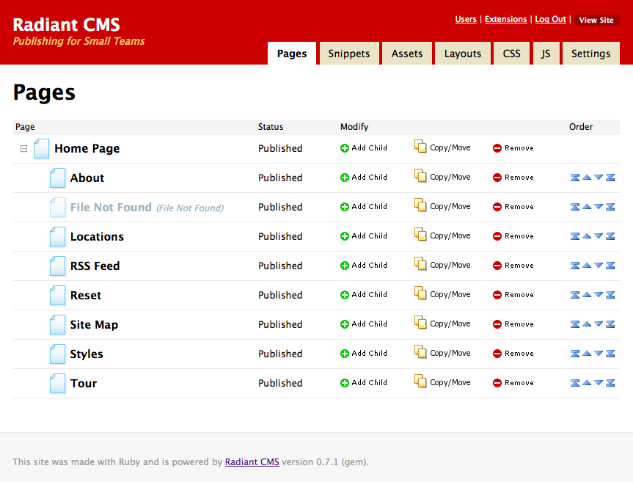
If you build menus dynamically from the pages created in Radiant (e.g. by using Navigation Tags mentioned below), the Reorder extension is a must. The extension adds a database field to keep track of the ordering of pages in the page tree, and it adds arrows in the user interface to let the web master change this ordering. It also ensures that the pages will be returned in the specified order by default.
Location: http://github.com/radiant/radiant-reorder-extension/

Paperclipped
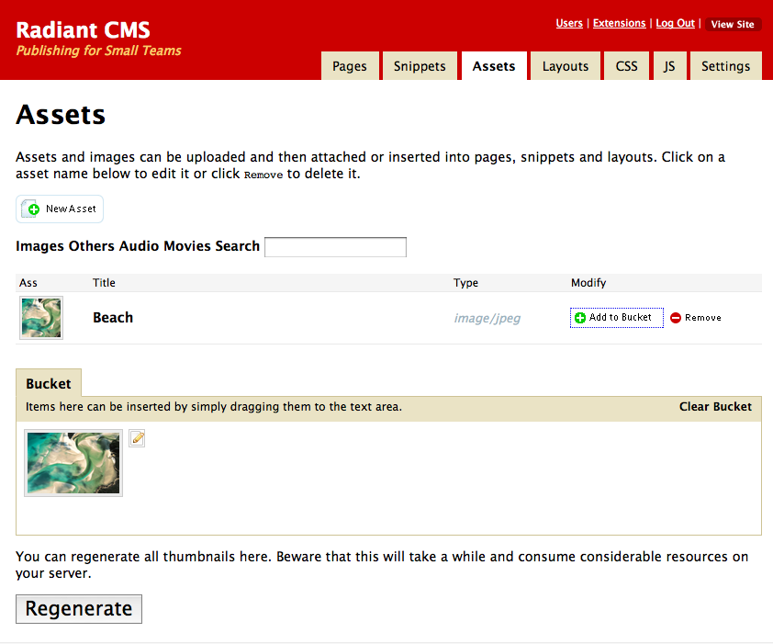
Since Radiant does not include any asset handling, several extensions exists to allow the web master to upload, manage and display images, videos, documents and other types of files. The Page Attachment extension - based on the attachment_fu plugin - is widely used and supported, but I recommend the newer and more user-friendly Paperclipped extension for this task. It is based on the paperclip plugin, and it allows the web master to easily upload and insert assets while editing a page. Further, it adds an "Assets" tab providing an overview of all uploaded assets and the ability to filter and search through assets.
Location: http://github.com/kbingman/paperclipped/

Copy/Move

The Copy/Move extension is, like Reorder and Paperclipped, an extension you can hardly go without on a production web site. It allows the webmaster to copy a page, with or without children or to move the page somewhere else in the page tree. Without this extension the web master is reduced to manually copy page content when the site structure is refactored, which is not something anyone should endure.
Location: http://github.com/pilu/radiant-copy-move/

While the first set of extensions were for the benefit of the web master, we now move on to some extensions aimed at the developer(s) of the web site.

Navigation Tags

You can generate static navigation menus in Radiant using the built-in <r:navigation> tag, and you can also generate a menu that changes dynamically with the page tree using a variety of Radius-tags. The former approach is not well suited unless the web master knows where and how to edit the static menu, and the latter might be a bit complicated for newcomers to Radiant. One solution is to use the Navigation Tags extension. It adds an <r:nav> tag which will render pages on a certain level in the page tree, or the entire page tree if need be, taking supplied options into account, .
Location: http://github.com/derencius/navigation_tags/

Nested Layouts

This extension will help developers to stay DRY (Don't Repeat Yourself) when building the website. Any site beyond the very basic will have certain variations to the layout of different pages and sections, and while this can be solved by clever use of page parts and snippets to a certain degree, making multiple Radiant layouts will often be a more intuitive solution - especially from the point of view of the web master. Without Nested Layouts you will need to separate any code shared between layouts into snippets that you include in each layout, but with this extension you can make a master layout with the basic markup required by all pages, and then create several child layouts with variations in the design.
Location: http://github.com/moklett/radiant-nested-layouts-extension/

Styles and Scripts

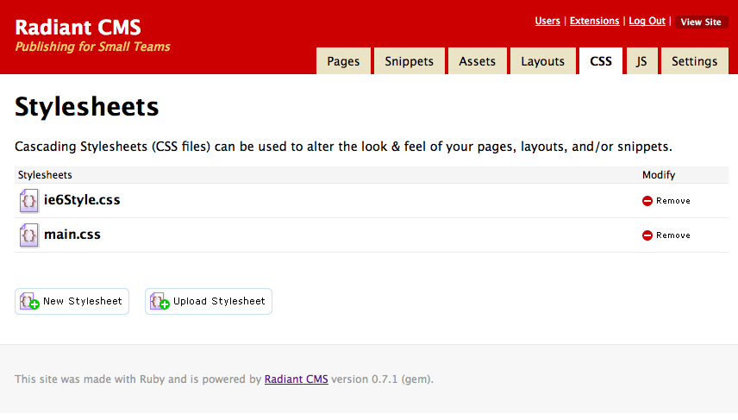
Radiant allows us to work with pages, snippets and layouts, but where do we put our stylesheets and javascripts? The default usage in Radiant is to simply add them as pages in the page tree with layout that sets a content type of either text/css or text/javascript. You can see an example of this approach if you choose one of the templates available when running rake db:bootstrap on a vanilla Radiant install. Another approach is to manage these files statically and put them in their respective directories within the public directory. A third approach is to use the Styles and Scripts extension which adds "CSS" and "JS" tabs where stylesheets and javascripts can be managed independently of content and layouts. It also provides tags for easily referring to these styles and scripts from layouts and pages. At the time of writing this article, the Styles and Scripts extension in the extension registry is not compatible with the newest version of Radiant. dko's fork of the extension at http://github.com/dko/radiant-sns-extension/ should be used instead.
Location:http://github.com/dko/radiant-sns-extension/

Concurrent Draft

Radiant's built-in workflow support is limited to setting the status of each page to either draft, reviewed, published or hidden, and this is enough in most cases. However, once a web site is running it is not possible to work on a new draft of a page while still having the old page displayed. The Concurrent Draft extension changes this and allows the web master to work on a draft and schedule when the new version of the page should be promoted to the live website to be visible by all. The extension does not add real versioning of pages, but it improves the workflow to be more suitable for medium and large web sites. At the time of writing, this plugin was not compatible with the newest verison of Radiant, 0.8.0. It has been used succesfully with the previous version 0.7.1.
Location: http://github.com/avonderluft/radiant-concurrent_draft-extension/

The last extensions mentioned in this article are more of a technical nature.

Share Layouts

You can add your own models, controllers and views to a Radiant web site, preferably by building your own extensions specific to your site, something that will be explained in future articles of the Rails Magazine. Once you start building your own dynamic pages running along-side your static Radiant pages, you will face the need to use the same layouts across all pages, dynamic or static. Share Layouts allows you to refer to a Radiant layout instead of Rails layout in your custom controllers by means of the radiant_layout 'layout name' command. This way, you still have full control over the layouts and menus from Radiant, even for your dynamic pages.
Location: http://github.com/radiant/radiant-share-layouts-extension/

Exception Notification

Once you have your Radiant site in production, you will want to be notified of any errors that occurs on the site. Even if you haven't added any custom code to Radiant, a lot of things can still go wrong. The Exception Notification extension wraps the widely used plugin of the same name, but adds the Internal Error page type, which gives you full control of the page shown when errors occur within Radiant. The extension requires ActionMailer to be enabled (disabled by default by Radiant) and it needs to know where to send e-mails to. This is all explained in detail in the readme file bundled with the extension.
Location: http://github.com/digitalpulp/radiant-exception-notification-extension/

Settings

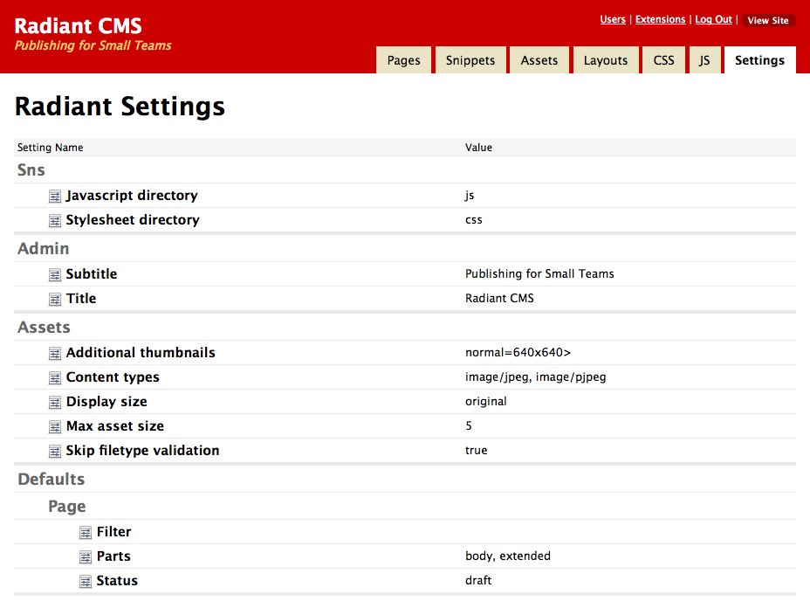
Radiant has a database table where it stores configuration such as the title displayed in the administration pages and what parts to add as per default to new pages. Many extensions also add their configuration to this table. Normally you would have to change these settings using the console, but the Settings extension adds a tab where the configuration can be edited directly from the browser. This makes life easier if you have to change configuration settings on a regular basis, or want the web master to be able to change them easily.
Location: http://github.com/Squeegy/radiant-settings/

Conclusion

There are more great extensions out there, many of which adds specific functionality to Radiant such as managing a picture gallery or sending out newsletters. Some can be found at the Radiant extension registry at http://ext.radiantcms.org/, but I also recommend doing a search for "radiant extension" on Github in your search of useful extensions.

[Layout: BOX]

Installing a Radiant extension

To install a Radiant extension, you will need to have a console open at the root of Radiant CMS-based Rails application. Extensions that are registered in the Radiant CMS Extension registry can be installed as easily as a Rails plugin with the command:

script/extension install [extension name]

This will add the extension to your application (as a submodule, if you use Git), will run any database migrations the extension might have and let it copy any images, javascripts or stylesheet to the public directory it might need to refer. Remember to restart the Rails application to get the extension loaded.

For extensions not in the registry, you will need to manually download/clone them into the /vendor/extensions/[extension name] and run these commands:

rake radiant:extensions:[extension name]:migrate
rake radiant:extensions:[extension name]:update

Once you deploy your application, you will probably also need to run migrations for all of the installed extensions (unless you start out with a clone of your development database). This can be done by running the following command on the server:

rake RAILS_ENV=production db:migrate:extensions

[Layout: BOX]

Sample Demo application

You can easily try out all the extensions and see them in action by cloning the demo application that has been made available on Github. If you have Git installed, you can simply clone the application as shown below - if not, you can download the application from the page at http://github.com/RSpace/railsmag-radiant/tree/article-1. You will need to have the Radiant gem and the SQLite gem installed (the latter is not necessary if you know how to change the application to use another database system), which is also shown below. Finally, you will need to bootstrap Radiant, migrate all the extensions and start the server. The following set of commands show how to do it:

gem install radiant
gem install sqlite3-ruby

git clone git://github.com/RSpace/railsmag-radiant.git
git submodule init
git submodule update

At this point we have the Radiant application locally, but the database is not initialized. One little snag with Radiant extensions is that they most often need to be disabled in order for Radiant to be able bootstrap the database. This is because Radiant will load the extensions before executing any rake tasks, and extensions relying on something in the database, typically the config-table, will fail.
So, open config/environment.rb and remove the comment at the config.extensions = [] line. Now bootstrap the database:

rake db:bootstrap

Now, out comment the line again in config/enviroment.rb. Migrate all the extensions, and finally; start the server and open the site http://localhost:3000 in your browser:

rake db:migrate:extensions
script/server

About the Author

Casper Fabricius is freelance Ruby on Rails developer working out of Copenhagen, Denmark with 8 years of web development experience and 3 happy years with Rails. He is passionate about the web, the agile approach and the Ruby community, and says wise things at his weblog at http://casperfabricius.com and stupid things at Twitter as @fabricius.

